STUDENT DETAILS

STUDENT NAME: ISAAC OMONDI OCHIENG

ADMISSION NUMBER: BSCCS/2024/52803

COURSE: COMPUTER SCIENCE

UNIT CODE: BIT3208

LECTURER NAME: MICHAEL NYORO

ACADEMIC YEAR: YEAR 3 SEMESTER

PROJECT DETAILS
PROJECT TITLE: CAR SELLING PLATFORM
SELECTED TECHNOLOGIES:
HTML, BOOTSTRAP, CSS,
MYSQL, JAVASCRIPT

GITHUB REPOSITORY LINK
https://github.com/isaacomosh/loginsystem

TABLE OF CONTENTS

STUDENT DETAILS 1
STUDENT NAME: ISAAC OMONDI OCHIENG 1
ADMISSION NUMBER: BSCCS/2024/52803 1
COURSE: COMPUTER SCIENCE 1
UNIT CODE: BIT3208 1
LECTURER NAME: MICHAEL NYORO 1
ACADEMIC YEAR: YEAR 3 SEMESTER 1
PROJECT DETAILS 1
GITHUB REPOSITORY LINK 1
Week 1: Local Environment Setup 3
3
Fig 1: Installation of XAMPP 3
4
Fig 2: Apache and MySQL Running 4
Fig 4: Hello World Test 4
5
Fig 5: Database Connection Test 5
Student reflection 5
Week 2: Wireframes and GUI Design 7
7
Fig 1: Hand-drawn Wireframe 7
8
Fig 2: Dashboard Layout Design 8
8
Fig 3: Mobile View Mockup 8
9
Fig 4: Color Theme and Navigation Structure 9
GUI Prototype in Figma 10
Fig 5.1: Register page figma design 10
Fig 5.2: Login page figma design 10
Fig 5.3: Dashboard figma design 11
Student Reflection: 11

Week 1: Local Environment Setup
Installation and Testing of Local Development Environment

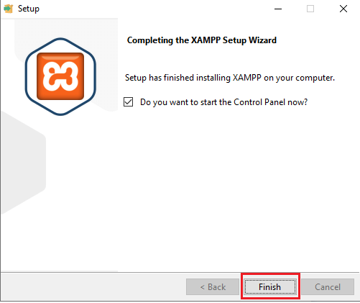

Fig 1: Installation of XAMPP

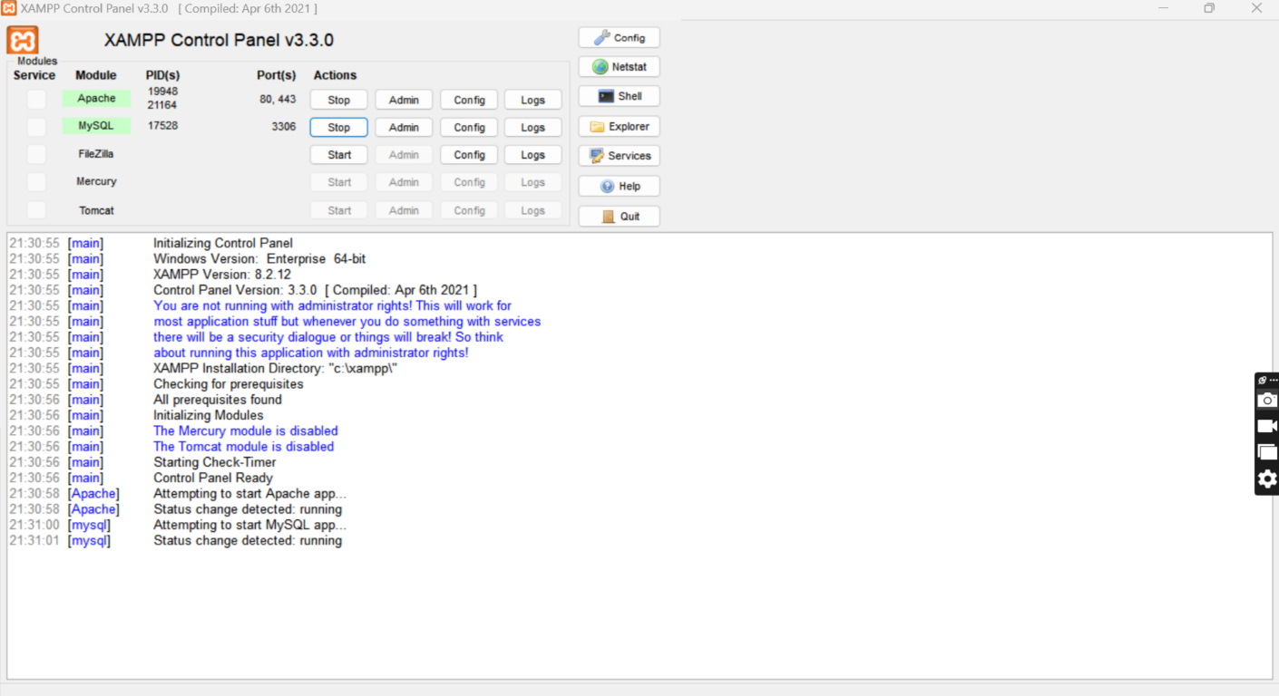

Fig 2: Apache and MySQL Running

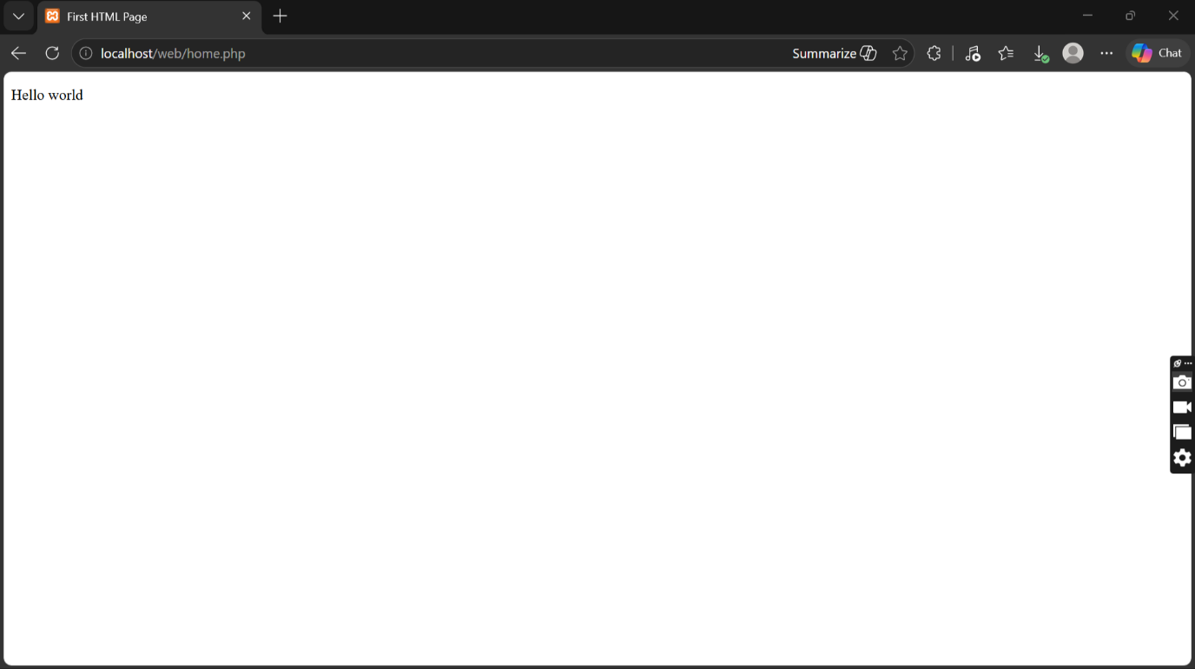

Fig 4: Hello World Test

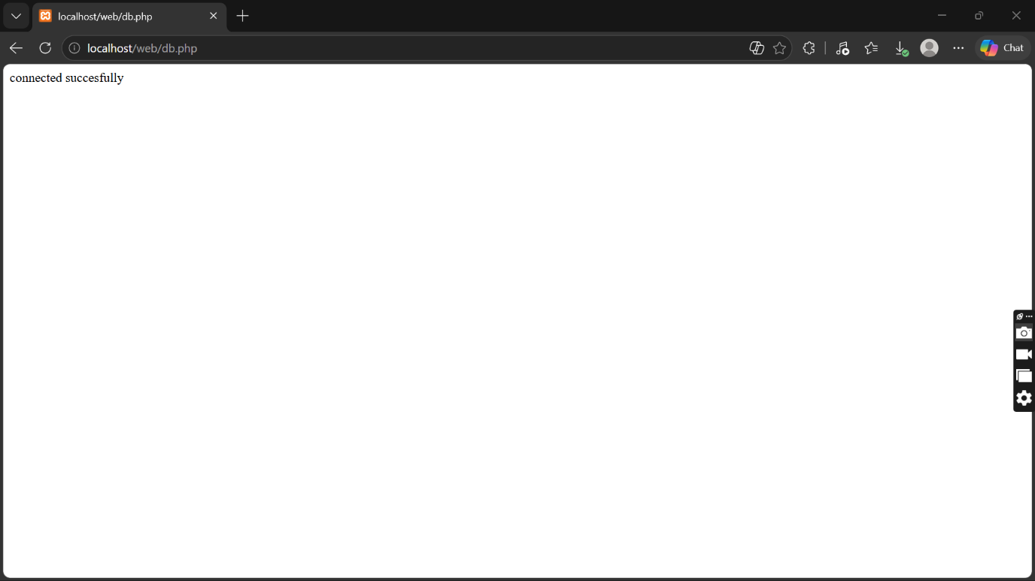

Fig 5: Database Connection Test

Student reflection
I have learnt on how to configure database on XAMPP. I also learned how Apache and MySQL services work together to support web development and database management.
The technologies used during the practical included XAMPP, Apache Server, MySQL Database, PHP, HTML, and a web browser for testing localhost pages. These technologies helped me understand the interaction between the frontend, backend, and database systems in web development.
One of the challenges I encountered was configuring the server correctly and ensuring that Apache and MySQL services started successfully without port conflicts. At first, I also experienced difficulty connecting the database to the PHP page due to incorrect connection details. However, after troubleshooting and correcting the configuration settings, the connection became successful.
The screenshots demonstrate the successful completion of each important step in the setup process. Figure 1 shows that the installation of the development environment was completed successfully. Figure 2 demonstrates that Apache and MySQL services were running properly from the control panel. Figure 3 confirms that the localhost server was working correctly in the browser. Figure 4 shows the successful execution of the first PHP or HTML “Hello World” page, proving that the web server could process files correctly. Finally, Figure 5 demonstrates a successful database connection between PHP and MySQL, confirming that the backend environment was functioning properly.

Week 2: Wireframes and GUI Design
User Interface Planning and System

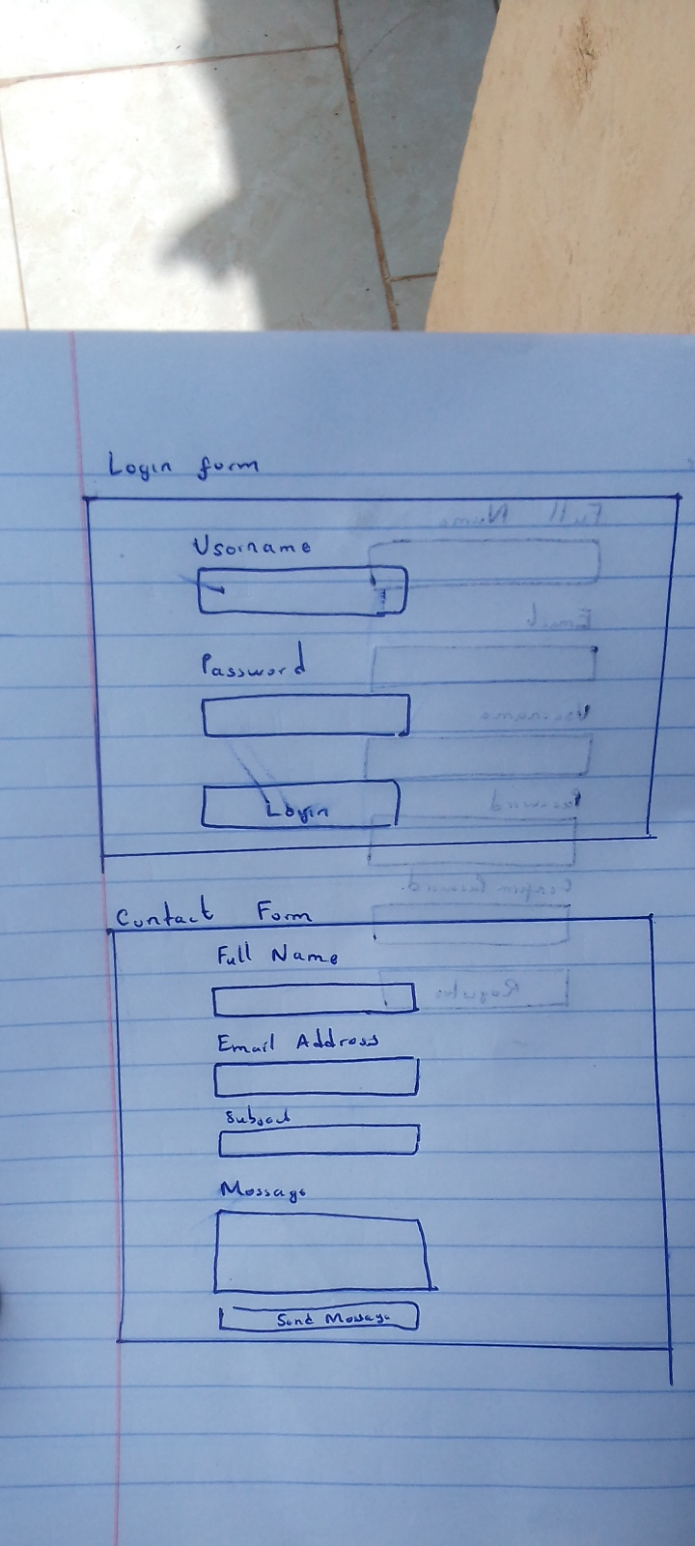

Fig 1: Hand-drawn Wireframe

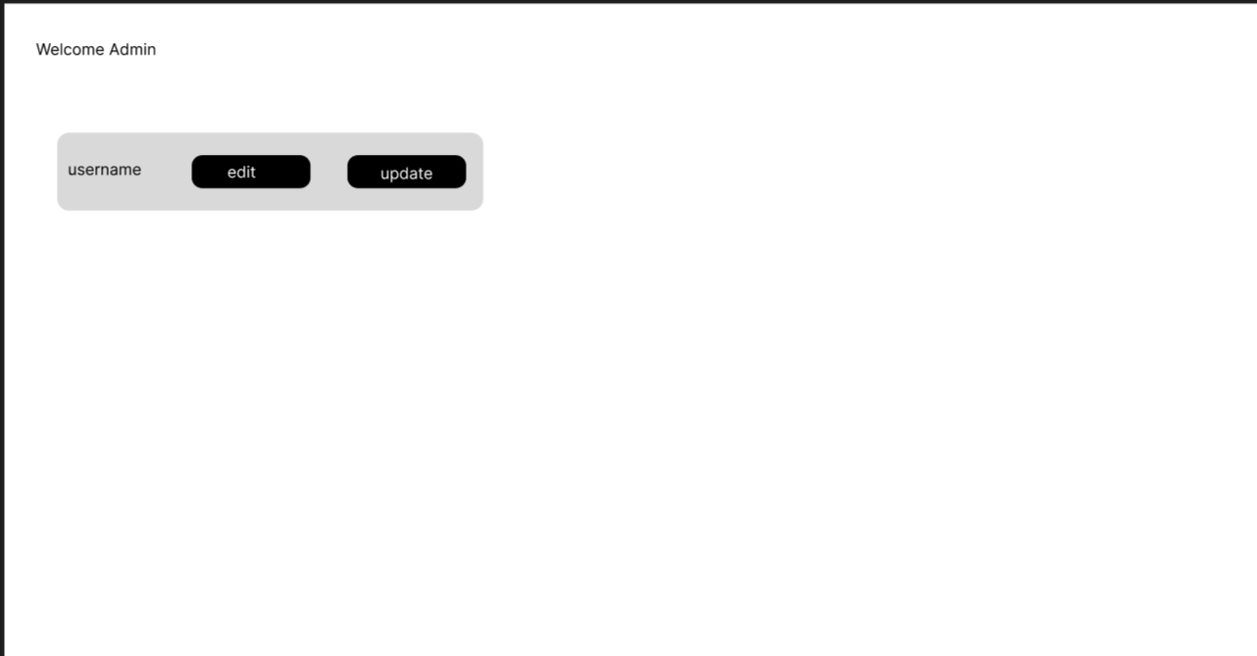

Fig 2: Dashboard Layout Design

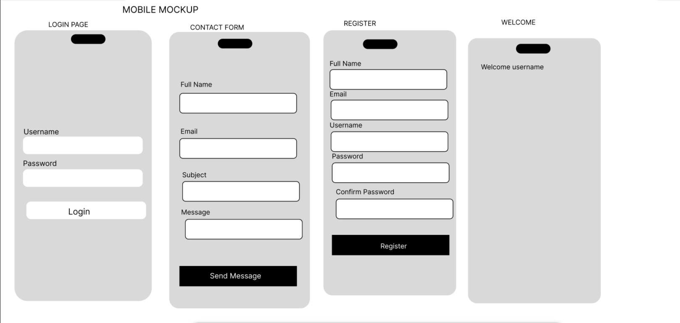

Fig 3: Mobile View Mockup

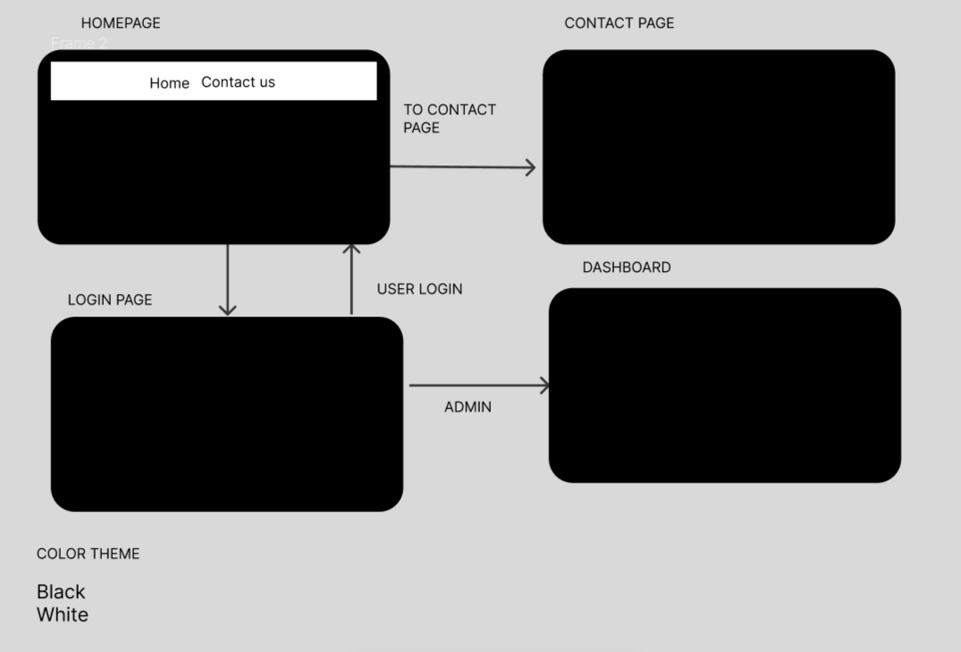

Fig 4: Color Theme and Navigation Structure

GUI Prototype in Figma
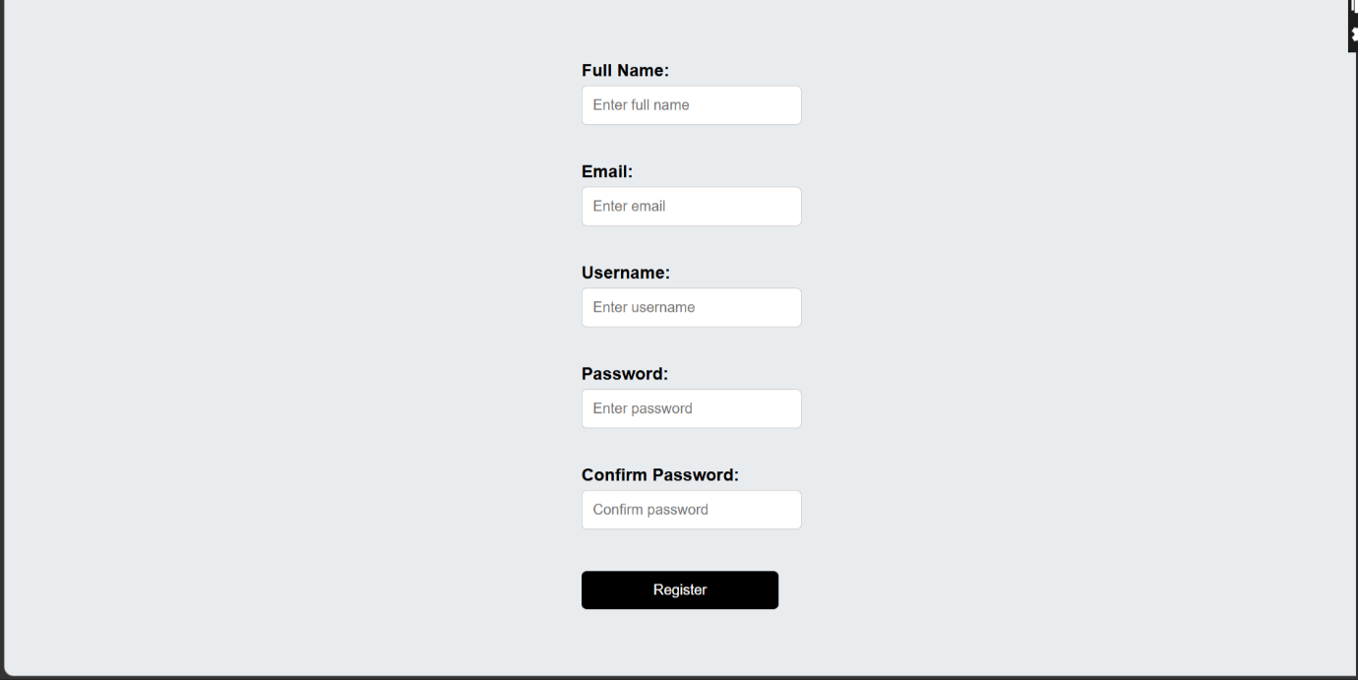

Fig 5.1: Register page figma design

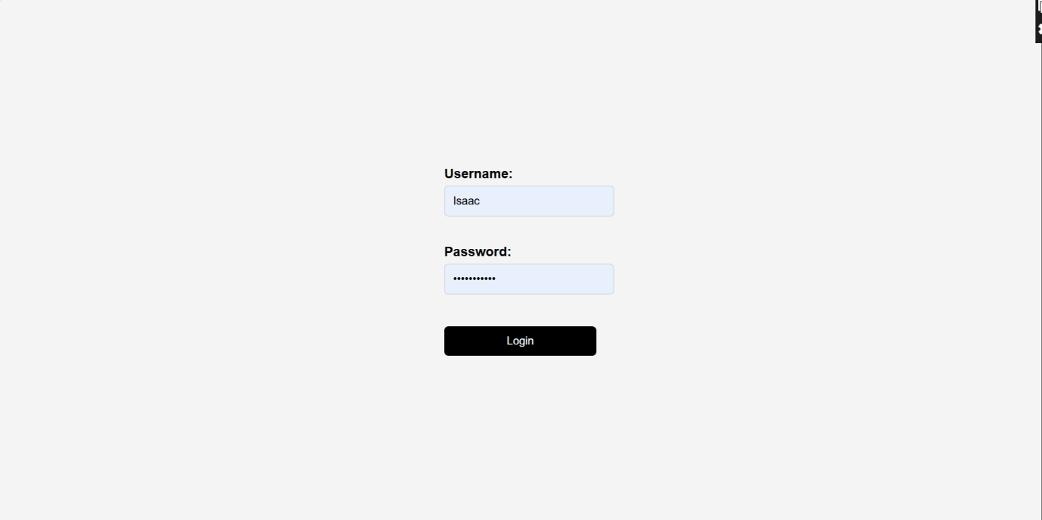

Fig 5.2: Login page figma design


Fig 5.3: Dashboard figma design

Student Reflection:
The system design was selected to create a simple and user-friendly experience for both users and administrators. Fig 1 and Fig 5.1 5.2 5.3 focused on clean layouts for easier interaction during register login. Fig 2 was designed in a manner to improve accessibility and reduce navigation time between modules. Fig 3 ensured the system is responsive and usable on mobile devices. Fig 4 used black and white colors and organized navigation flow to improve readability and usability.

